**Thesis Writing Workshop**

**Station Directions**

**C:\Users\gehazlin\AppData\Local\Microsoft\Windows\Temporary Internet Files\Content.IE5\0XK1UH7R\MC900234134[1].wmf**

**LEGOLand**

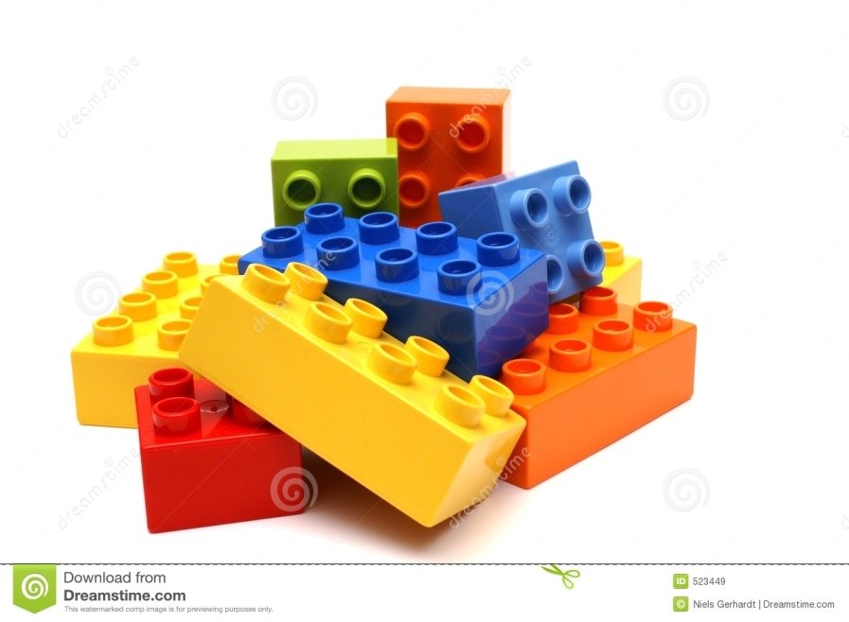There are thesis statements made out of LEGO bricks at each table. Construct the best statement you can with the LEGO bricks provided. Next, record your LEGO bricks thesis statements below. If you have time, make more than one. Don’t forget to mix up the LEGO bricks at your table before you depart.

**Thesis CSI**

Pick three pieces evidence from one of the color categories. Use those three pieces of evidence to write a clear concise statement. Record it in the space on your handout.



**Pick the Best**

As you pick the best thesis statement out of a pair, you will collect a piece of a QR code. When you are finished, put the QR code pieces together and scan with the iPad to see if you picked the best thesis statements.

C:\Users\gehazlin.FCPSEDU\AppData\Local\Microsoft\Windows\Temporary Internet Files\Content.IE5\XXL2UA6R\MC910217630[1].wmf

**Map It**

Break the thesis statements at this station into key components by diagraming them. Simply read the thesis and then dissect it into parts, putting each part into the correct location on the diagram on the handout. Space is provided for you to “map” up to four statements.

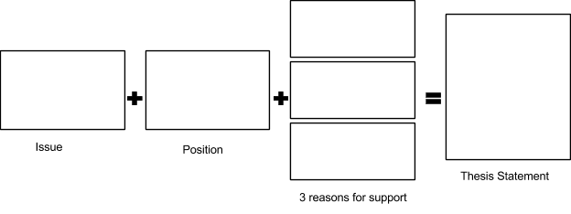

**Rewrite It**

Scan the QR Code to access the Google form. Pick three thesis statements from the station and rewrite each one into a stronger statement using clear and concise language.



**Exit**

Make sure to do this station last! Pick up an exit pass and begin filling it out. This is due at the beginning of class tomorrow.

C:\Users\gehazlin.FCPSEDU\AppData\Local\Microsoft\Windows\Temporary Internet Files\Content.IE5\XXL2UA6R\MC900389390[1].wmf