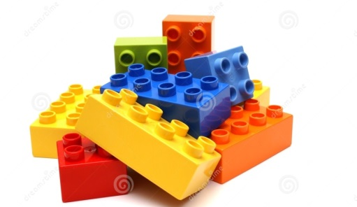
Dogs are better pets than cats because…

The Hunger Games is a riveting and educational book because…

Kilmer Middle School is a nurturing environment because…

Schools should not serve soda at lunch because…

